Create a resource group by using name , location and tags through PowerShell or azure portal

**PowerShell commands:**

**Account-connect:**

Connect-AzAccount

**Resource group creation:**

New-AzResourceGroup -ResourceGroupName "sampleaks" -Location "east us" -tag @{'resources'='aksclustures'}

Get-AzResourceGroup -ResourceGroupName sampleaks

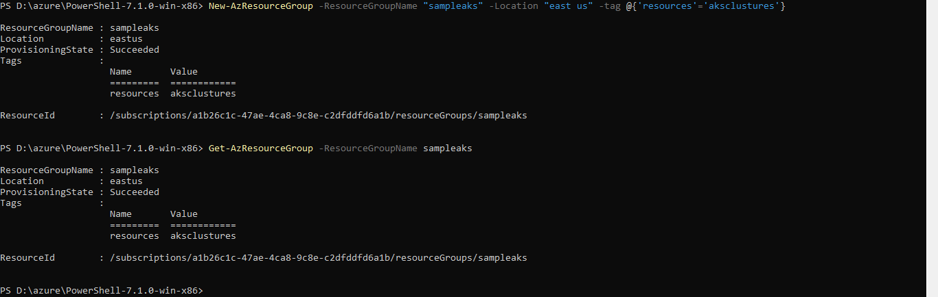

**Deploy arm template with locally stored json files:**

New-AzResourceGroupDeployment -Name test -TemplateParameterFile "D:\azchlg\aks\azuredeploy.parameters.json" -TemplateFile "D:\azchlg\aks\azuredeploy.json" -Debug -ResourceGroupName sampleaks

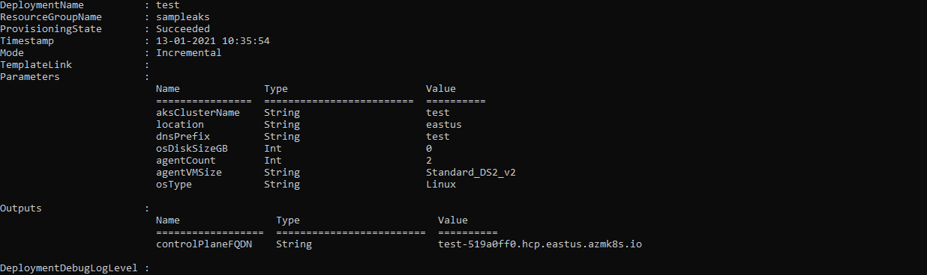

**To get Node Pool details:**

Get-AzAksNodePool -Name agentpool -ResourceGroupName sampleaks -ClusterName test

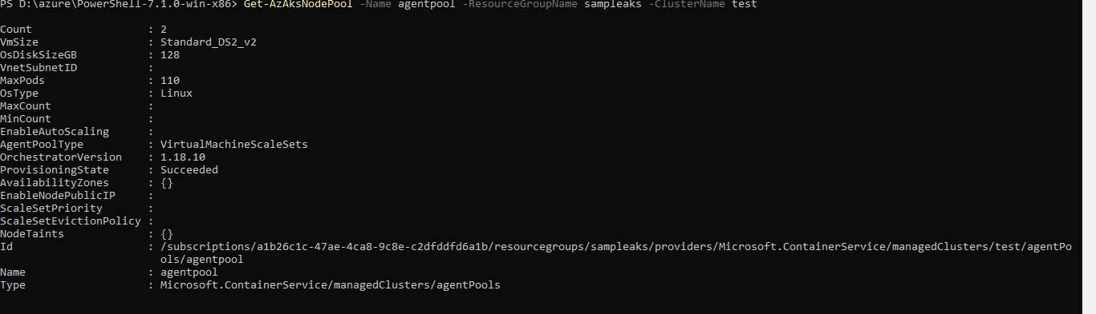

**To get Cluster details:**

Get-AzAksCluster -ResourceGroupName sampleaks -Name test

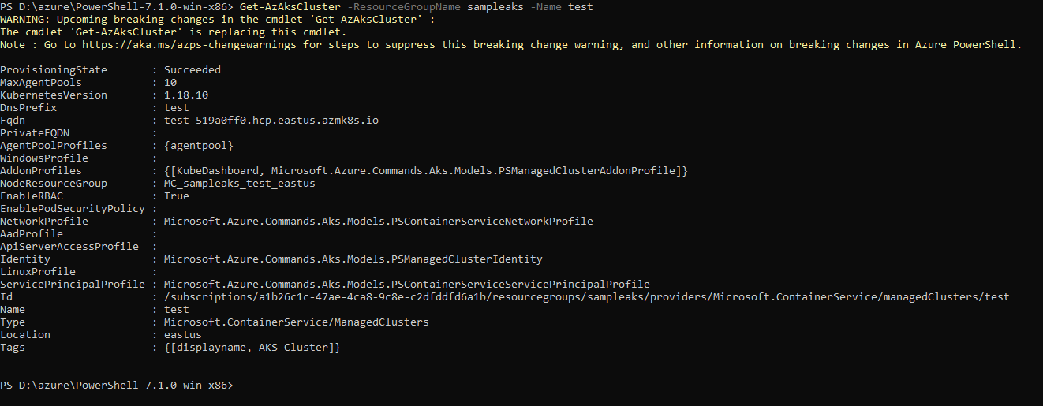

Configure

Set-AzAksCluster -ResourceGroupName sampleaks -NodeMinCount 1 -NodeMaxCount 3 -NodePoolMode System -Name test -NodeCount 3 -NodeName agentpool

**To create a new agent Pool:**

New-AzAksNodePool -ResourceGroupName sampleaks -ClusterName test -Name agentpool1 -Count 0 -OsDiskSize 100 -MaxPodCount 100 -VmSize Standard_DS2_v2 -OsType Linux

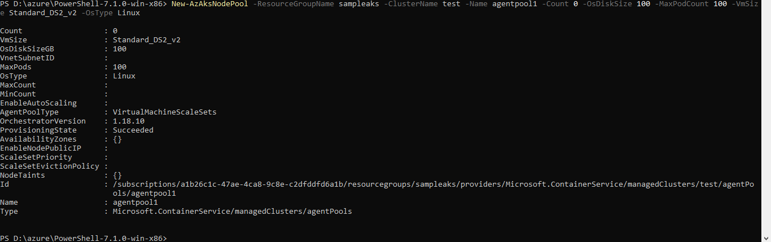

**Auto Scaling:**

Set-AzAksCluster -ResourceGroupName sampleaks -Name test -NodeCount 2 -NodeName agentpool -NodeMinCount 1 -NodeMaxCount 10 -EnableNodeAutoScaling

